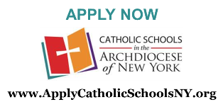
Admissions for 2023/2024 will open on December 1st!
Why don’t you take 10 minutes and submit an application for your child for the 2023/2024 school year?
Hold your seat now!
Only admissions for Rising Kindergarteners and new students has opened.
(Re-registration for currently enrolled students that do not fall in these categories will begin in early 2023)
You are also welcomed to submit your financial aid application as well! There is a $40 fee to submit the financial aid application, but no registration fee is due at the time you submit the admissions application.
If you plan on registering your child for 2023/2024, please take a moment and go to www.ApplyCatholicSchoolsNY.org today!

